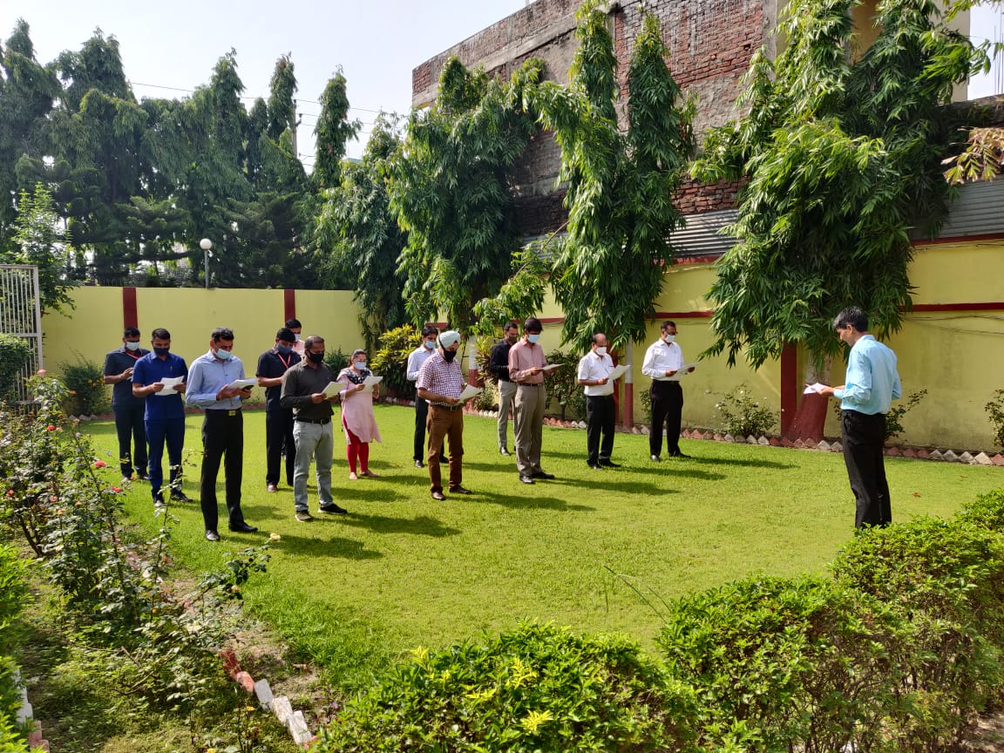
Sh. Nitesh Kumar, Consul General administered a pledge on observance of Anti- Terrorism Day inside the Consulate premises today on at 0900 hrs to officers and officials of CGI, Birgunj.
